General Welfare Requirement: Suitable People
Providers must ensure that adults looking after children, or having unsupervised access to them, are suitable to do so.
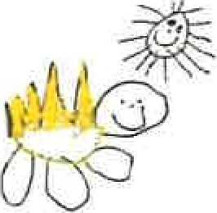
Gorran Pre School
Employment

2.3 Student placements

Policy Statement
At Gorran Pre-School Hoglets we recognise that qualifications and training make an important contribution to the quality of the care and education provided by early years settings. As part of our commitment to quality, we offer placements to students undertaking early years qualifications and training. We also offer placements for school pupils on work experience.
We aim to provide for students on placement with us experiences that contribute to the successful completion of their studies and that provide examples of quality practice in early years care and education.

EYFS key themes and commitments
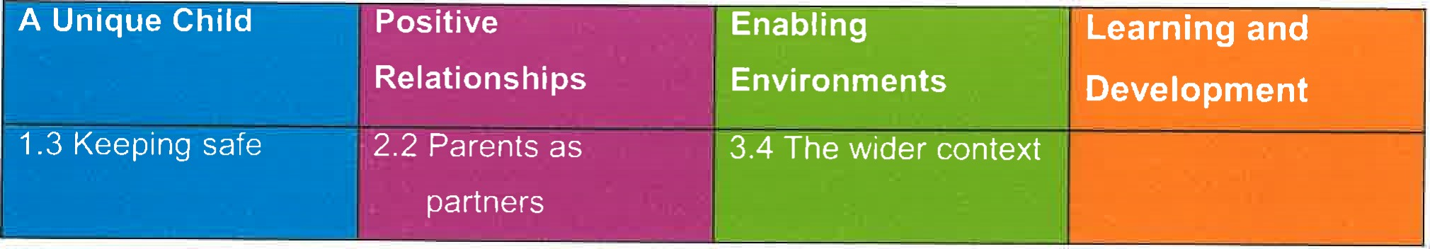
Procedures
We require students on qualification courses to meet the 'suitable person' requirements of Ofsted and have CRB checks carried out.
- We require schools placing students under the age of 17 years with the setting to vouch for their good character.
- We supervise students under the age of 17 years at all times and do not allow them to have unsupervised access to children.
- Students undertaking qualification courses who are placed in our setting on a short term basis are not counted jn our staffing ratios.
- Trainee staff employed by the setting may be included in the ratios if they are deemed competent.
We take out employers' liability insurance and public liability insurance, which covers both trainees and voluntary helpers.
- We require students to keep to our confidentiality policy.
- We co-operate with students' tutors in order to help students to fulfil the requirements of their course of study.
We provide students, at the first session of their placement, with a short induction on how our setting is managed, how our sessions are organised and our policies and procedures. We communicate a positive message to students about the value of qualifications and training.
- We make the needs of the children paramount by not admitting students in numbers that hinder the essential work of the setting.
We ensure that trainees and students placed with us are engaged in bona fide early years training, which provides the necessary background understanding of children's development

and activities.
Date to be reviewed: October 2020

Signed on behalf of the management committee.
Gorran Pre-School
Held on: October 2019

Michelle Beard

Name of signatory Michelle Beard Role of signatory (e.g. chair) Pre-School Leader/Nominated Person

